Unit 1: Lesson 3
Positive Thoughts

Goal: To learn the part thoughts play in the Thoughts-Actions-Feelings Circle. To learn how our thoughts lead to our actions.

Story:
On a glorious Saturday morning about 10 o’clock Sam rolled over and stretched. The sun was shining in his bedroom window, warming his skin. He was so comfy he didn’t want to get out of bed. But he’d promised his mom that he’d mow the lawn this morning.
However, chasing a lawn mower around the yard on a beautiful Saturday morning was the last thing he wanted to do. Sam had had an up-and-down week, great days and not-so-great days. Mowing the grass didn’t appeal to him in the least. He moped as he got dressed; he complained all through breakfast; he sulked all the way out the door. Then he sat in the hammock, looked at the lawn mower, and said to himself, “This is a really big lawn.” Sam got depressed just thinking about it.
Then Sam realized how he was thinking. “I’m making myself miserable,” he thought, shaking his head. “I just learned this lesson last week. Why would I want to start another unhappy day?”
He stood, looking over the lawn. “I don’t have to think this way. I can turn it around right now. I can think the way I do when my days are happy. Maybe I can mow some goofy things in the grass-have some fun.”
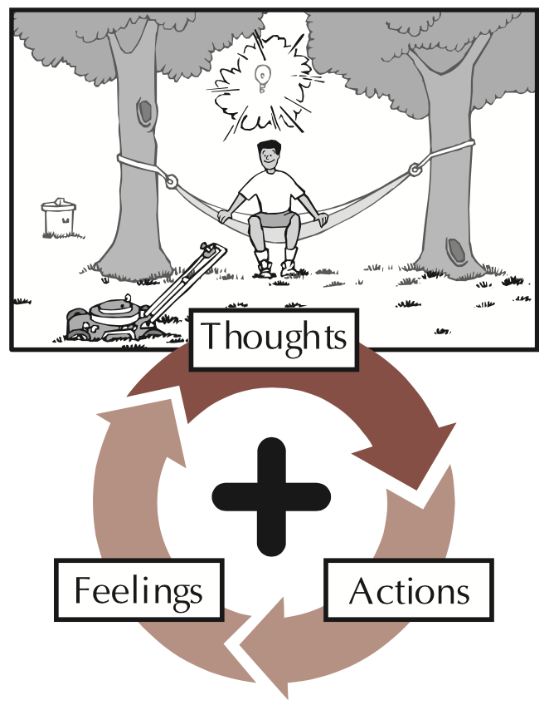
Thoughts are the starting point in the Thoughts-Actions-Feelings Circle. All kinds of thoughts come into our heads. Our thoughts can be positive or negative, but never neutral. Positive thoughts help us do good things. Negative thoughts don’t. We can’t always control which thoughts come into our heads, but we can choose which ones we allow to remain there. We can be aware of our thoughts and how they affect our actions.
Our actions come from our thoughts. We choose the thoughts we act on. If we choose thoughts that are unkind, our actions will be unkind. If we choose thoughts that are loving and generous, then our actions are loving and generous! Because our actions affect both ourselves and others, we have a responsibility to them and to us to choose positive thoughts.
Did you notice the most important word in the previous sentence? It’s the word choose. We get to choose which thoughts we will act on. When we choose positive thoughts, we do positive actions, and we enjoy positive feelings about ourselves. When we choose negative thoughts, we do negative actions, and we have negative feelings about ourselves. Therefore, we choose whether we want to be happy or unhappy!

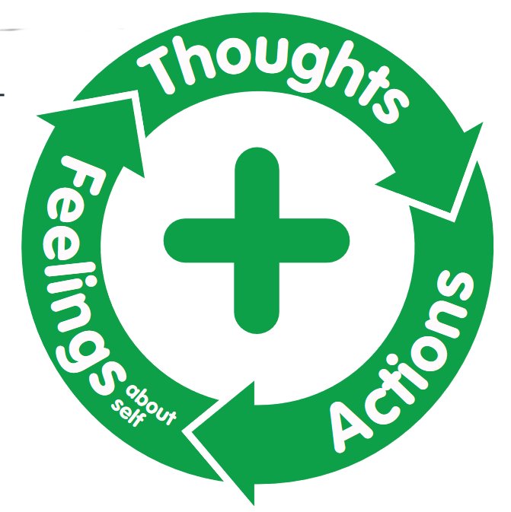
Let’s look at the Thoughts-Actions-Feelings Circle again. It’s important to choose positive thoughts because our thoughts direct our actions, and our actions determine how we feel about ourselves. It all begins with our thoughts.
No matter how positive we are, both positive and negative thoughts come to mind. Others linger. Others command our full attention. By being aware of our thoughts, we can choose which thoughts we want to act on.
Just because negative thoughts come into our minds doesn’t mean we have to act on them. We can look at a situation either positively or negatively. We can choose to “flip” a negative thought about the situation over into a positive one. For example, “I hate to exercise” can be flipped over into “I love feeling good.” We flip our thoughts over by looking for the positive and thinking what that would lead us to. That’s what Sam did in his situation. He flipped his negative thoughts about mowing the lawn over into positive thoughts.
The more we practice choosing positive thoughts, the easier it becomes. As we grow more aware of our thoughts, we see that we can replace our negative thoughts with positive thoughts. The more we do it, the better we’ll get at flipping negative thoughts over into positive thoughts.
We should always be in the process of making our thoughts positive. We do that by examining our thoughts as we think them and by paying attention to how they would affect our actions and our lives. If we fill our minds with positive thoughts, we won’t do negative actions. If we fill our minds with negative thoughts, we won’t do positive actions.
Learning to choose positive thoughts takes time. Choosing positive thoughts helps us feel good about ourselves, which gives us the confidence to choose other positive thoughts. When we get good at choosing positive thoughts, we feel even better about ourselves. How and what we think affects what we do and how we will feel about ourselves, and that affects how our lives turn out. Thinking positive thoughts is the starting point of a positive life. Let’s think positive thoughts!

Questions:
- What is the difference between positive and negative thoughts?
- Why is it important to be aware of both positive and negative thoughts?
- Why is it important to choose positive thoughts rather than negative thoughts?
- How do we flip a negative thought over to a positive one?
- How does choosing positive thoughts affect our self-concept?
- How can we improve our ability to think positive thoughts?

Discussion:
- Do you have more positive or more negative thoughts?
- How can you choose positive thoughts?
- How can you avoid choosing negative thoughts?

Parent positive action
Ask yourself: what are some positive thoughts you have about yourself as a parent? About your children? What are some negative thoughts you have about yourself as a parent? About your children? How can you flip those negative thoughts about yourself and your children to positive thoughts? How can you encourage your children to flip negative thoughts about themselves into positive thoughts? How can you help yourself and your children to have more positive thoughts?
Plan and do: This week think positive thoughts about yourself as a parent. Write them down. During the week as you think of more positive thoughts, add them to your list. Also write down any negative thoughts about yourself as a parent and how you can flip them over into positive ones.
Next, write your children’s names at the top of a piece of paper and make a list of all the positive thoughts you have about each of them. Keep your lists where you can see them and add more positive thoughts to them. If there are moments when you thoughts are not positive about your children, look back over the lists. They will remind you of the good and lovable things you see in your children so you can flip your negative thoughts over into positive ones.
You might want to keep these lists and add to them several times a year all through the course of your children’s lives. You can keep these lists for yourself, or you can give them to your children as you write them. You might even want to save them and give them to your children when they are adults.
As you spend time with your children this week, encourage them to think positive thoughts

See how positive “Thoughts” lead t positive “Actions” and how our positive “Actions” lead to our positive “Feelings” about ourselves. Note how our positive “Feelings” lead back to our positive “Thoughts.”
Let’s come up with some examples of positive thoughts. For example, “I like to eat fruit” is a positive thought. “I like to treat my friends in ways I like to be treated” is another.”

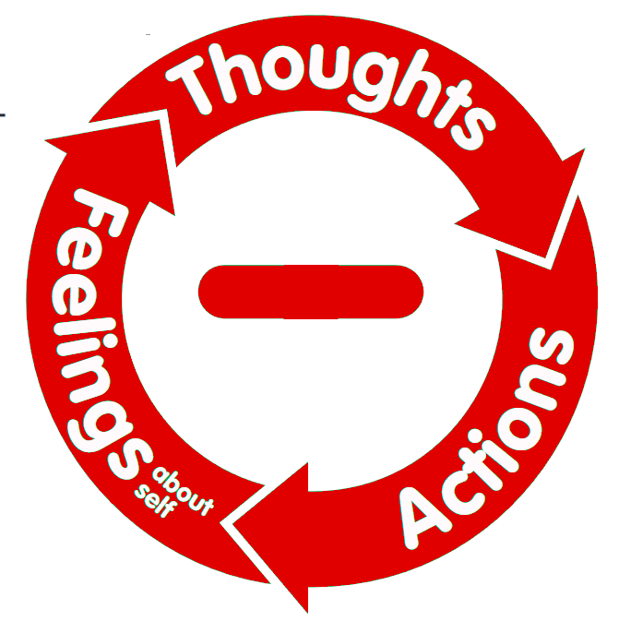
Now let’s think about the Unhappy Circle for a minute. Let’s find examples of some negative thoughts. For example, “I hate doing dishes” is a negative thought. So is “I just want to sit here in front of the TV for the whole rest of my life.”
Now let’s talk about ways we can flip those negative thoughts over into positive thoughts. For example, we can flip the thought “I hate doing the dishes” into “I like to have the dishes done.”
Now let’s try it with your own examples of negative thoughts. Each of you name some examples of negative thoughts you have had. Now, flip it!
Family Positive Actions Discussion:
- How do our individual thoughts affect the entire family?
- How can we help one another choose positive thoughts?
- How can we encourage one another to flip negative thoughts over into positive thoughts?
- What are some positive thoughts we have about our family?
- What are some negative thoughts we have about our family?
- How can we flip those negative thoughts over into positive thoughts?
Let’s think of as many positive thoughts about our family as we can. Come up with sentences such as “We have fun together!” or “We like one another!”
Make a list and posit it on the refrigerator. Leave space at the bottom to add positive family thoughts throughout the week. When you get in the refrigerator during the week, this list will help you think positive thoughts about your family.

Community Positive Actions:
Let’s take a walk or drive through our neighborhood. See how many positive thoughts we can think about our community: the friends we’ve made, the people who have helped us out, the school we go to, the place where we worship, the hospital that serves us, our workplace, the stores where we’ve made friends. Let’s remember all the places where we’ve had positive experiences. Let’s practice choosing positive thoughts and recall positive memories about our community.

Positive Feelings
Thoughts are the starting point of the Thoughts-Actions-Feelings Circle model. Both kinds of thoughts come into our heads, positive and negative. Positive thoughts help us do good things. Negative thoughts don’t, and they can lead to negative actions and feelings about ourselves.
By being aware of our thoughts, we can choose which thoughts we want to think and act on. When we choose positive thoughts, we do positive actions, and we enjoy positive feelings a out ourselves. When we choose negative thoughts, we do negative actions, and we have negative feelings about ourselves. We choose whether we want to be positive or negative, happy or unhappy.
We can choose to flip our negative thoughts over into positive ones. We flip our thoughts by looking for a positive way to view our situation. We can always be in the process of making our thoughts positive. We do that by examining our thoughts as we think them and by paying attention to how they would affect our actions and our lives. We feel good about ourselves when our thoughts lead us to take positive actions. Our thoughts determine our actions, and our actions determine our feelings about ourselves.

Word of the Week: Valuable
Precious or of great worth.

